H.T No
Regulations:
A17

Sreenidhi Institute of Science and Technology
(An Autonomous Institution)
Code No: 6H213 Date: 19-Feb-2025 (FN)

B.Tech I-Year II- Semester External Examination, February-2025 (Supplementary)
ENGINEERING MATHEMATICS – II (Common to All Except BT)

Time: 3 Hours Max.Marks:75
Note: a) No additional answer sheets will be provided.
b) All sub-parts of a question must be answered at one place only, otherwise it will not be valued.
c) Missing data can be assumed suitably.

Bloom's Cognitive Levels of Learning (BCLL)

Remember | L1 | Apply | L3 | Evaluate | L5
Understand | L2 | Analyze | L4 | Create | L6

Part - A Max.Marks:25

Answer all QUESTIONS.
 |  | BCLL | CO(s) | Marks
1 | Determine the rank of the matrix 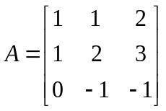 | L3 | CO1 | [2M]
2 | Compute the Eigen values and Eigen vectors of the matrix 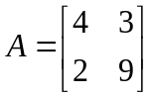 | L3 | CO2 | [2M]
3 | Form the partial differential equations by eliminating the arbitrary function from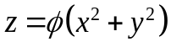 | L2 | CO3 | [2M]
4 | Define the Laplace transform of a function  and find 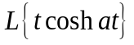 | L1 | CO4 | [2M]
5 | Find the 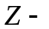transform of 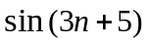 | L3 | CO5 | [2M]
6 | Five the Fourier series representation of an even function 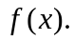 | L2 | CO6 | [3M]
7 | Find the rank of the matrix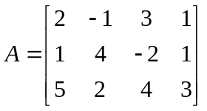 | L1 | CO1 | [3M]
8 | Solve the PDE 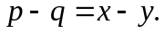 | L3 | CO3 | [3M]
9 | Explain the half range Fourier series concept. | L2 | CO4 | [3M]
10 | Point out the conditions for existence of Laplace transform of a function | L3 | CO6 | [3M]

Part – B Max.Marks:50
ANSWER ANY FIVE QUESTIONS. EACH QUESTION CARRIES 10 MARKS.

 |  |  | BCLL | CO(s) | Marks
11. | a) | Reduce the matrix 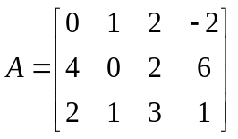 into normal form and hence find its rank | L3 | CO1 | [5M]
 | b) | Apply Gauss elimination method to solve the system of equations | L3 | CO1 | [5M]
12. |  | Diagonalize the matrix 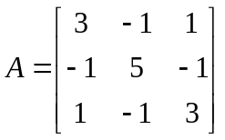 | L5 | CO2 | [10M]
13. | a) | Solve 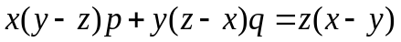 | L2 | CO3 | [5M]
 | b) | Use method of separation of variables to solve 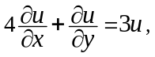given 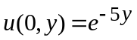 | L3 | CO3 | [5M]
14. |  | Using Laplace Transform, find the solution of the initial value problem  y¹¹ + 9y = 6.Cos3t, y(0) = 2, y¹(0) = 0. | L4 | CO4 | [10M]
15. | a) | Evaluate 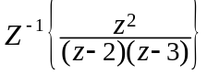by convolution theorem | L3 | CO5 | [5M]
 | b) | Find the inverse 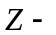transform of 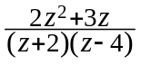 | L5 | CO5 | [5M]
16. |  | Develop the Fourier series expansion of 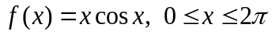. | L6 | CO6 | [10M]
17. | a) | Using Gauss- Jordan method, find the inverse of the matrix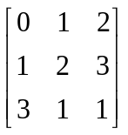 | L2 | CO1 | [5M]
 | b) | Verify Cayley – Hamilton theorem for the matrix 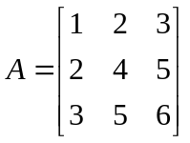 | L2 | CO2 | [5M]
18. | a) | Using convolution theorem find 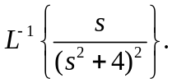 | L3 | CO4 | [5M]
 | b) | Find 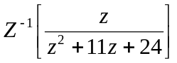 | L5 | CO5 | [5M]

-- 00 -- 00 –

